**Step 1: Check DW Admin Log Entry Status**

Task: Run the query *SELECT * FROM dw.admin.log*

Action: Ensure that the entry status is "started" for today's date.

**Step 2: Verify NDM File Arrival**

Task: Check if all NDM files have arrived at a specific location. If files are not at the designated location, Contact Broadridge team to resend the files.

Action: Verify the NDM files at the designated location.\\sql-clst-bpsa\data\impac\download\

**Step 3:**Task: Initiate the job (COPY_LOCAL_TO_NDM) on DW1 for file transfer.

Action: Start copying the NDM files to the desired destination.  
EXECUTE Master.dbo.xp_CmdShell 'copy

select [IREP_DB].[admin].[Get_SystemDate]() function

ROM [IREP_DB].[dbo].[System_Date]

'echo.' + ' > [\\10.1.10.9\uatsftp\icbc_fs_br\IMPACT\ICBUAT\CopyLog](\\\\10.1.10.9\\uatsftp\\icbc_fs_br\\IMPACT\\ICBUAT\\CopyLog)'

delete from #R where [file] <> 1

select Subdirectory,Subdirectory +@Dateext from #R

SELECT @Command = 'exec master..xp_cmdShell ' + '''rename \\10.1.10.9\uatsftp\icbc_fs_br\IMPACT\ICBUAT\'+ cast(@Fname as varchar)+ ' '+ '' + cast(@FNewName as varchar) +''''

**Step 4: Confirm File Copy Completion**

Task: Ensure that all NDM files are successfully copied to the destination.

Action: Check if the NDM files are present at the location: \\10.224.15.97\nybr\FS_IC_BR\IMPACT\ICBCPROD

**Step 5: NDM Files Loading from Stored Procedure (Runs Sequentially)**

Task: Start loading the received NDM files by running the job (load_NDM_files_to_staging).

Action: Initiate the job that loads entries into category load status after NDM messages (not loaded by package) are loaded into inbound table.

1. Stored Procedure [SP_Load_Daily_NDM_NDMInboundMSG]
   1. Change Date to file Date if Not Changed
   2. delete from [Irep_DB].[dbo].[stage_DailyNDMLog]
   3. insert into [dbo].[stage_DailyNDMLog] select * FROM [Irep_DB].[dbo].[IREP_NDMFileList] where Isloaded = 1
   4. Loop for SELECT fname from [dbo].[stage_DailyNDMLog]
2. Exec dbo.sp_load_NDMInboundMSG:
3. BULK INSERT [dbo].[v_IREP_NDMMessageInbound] FROM
4. DELETE FROM [dbo].[irepndmmessageinbound]
5. WHERE id IN (SELECT id
   * + 1. FROM [dbo].[irep_ndmfilelist]
6. Update [dbo].[IREPNDMMessageInbound] set ID = ( select ID from [dbo].[IREP_NDMfilelist] where ndmfilename like
7. 'Update [dbo].[stage_DailyNDMLog]
   * 1. set [IsloadedStaging] = 0 where [Fname] = '''
8. delete from [dbo].[IREPNDMMessageInbound] where len(message) < 150 and ID = ( select ID from [dbo].[IREP_NDmfilelist] where ndmfilename like
9. delete from [dbo].[IREPNDMMessageInbound] where len(message) < 72 and ID = ( select ID from [dbo].[IREP_NDmfilelist] where ndmfilename like
10. delete from [dbo].[IREPNDMMessageInbound] where len(message) < 72 and ID = ( select ID from [dbo].[IREP_NDmfilelist] where ndmfilename
11. SELECT @Cnt = Count(*)

FROM [dbo].[irepndmmessageinbound]

WHERE id IN (SELECT id

FROM [dbo].[irep_ndmfilelist]

WHERE ndmfilename LIKE @NdmFilename)

EXEC [dbo].[Sp_stage_tbl_audit]

* 1. ---added for category load status

insert into dbo.CATEGORY_LOAD_STATUS(CATEGORY, ASOF_BUSINESS_DATE, TIME_LOADED,JobEnabled)

* 1. insert into [TradeLoadStaging].[dbo].[NDM_File_Load_Error]
  2. INSERT FOR A SPECIFIC DATE AND FILE NAME

Update [dbo].[stage_DailyNDMLog]

Exec dbo.sp_load_NDMInboundMSG @GivenDate

insert into dbo.CATEGORY_LOAD_STATUS(CATEGORY,ASOF_BUSINESS_DATE, TIME_LOADED,JobEnabled)

insert into [TradeLoadStaging].[dbo].[NDM_File_Load_Error]

* 1. INSERT ALL THE FILES FOR A SPECIFIC DATE

BULK INSERT #FileInfo_2 FROM

same as Insert all file for today steps above.



**Step 6: NDM Files Loading from Package (Runs Concurrently)**

Task: Run jobs (Load_NDM_BECDLDEP, Load_NDM_CUSDLDEP, Load_NDM_EX2FILEP ,Load_NDM_FINDLDEP, Load_NDM_KKSDLDEP, Load_NDM_T9PDLDEP, Load_NDM_XGLDLDEP, Load_NDM_XPDLDEP, Load_NDM_YAPDLDEP) to load files from package. Make sure the files are in the archive folder

Action:Initiate the job that runs the package to load the files.   
[\\10.224.15.97\nybr\FS_IC_BR\IMPACT\ICBCPROD\archive](\\\\10.224.15.97\\nybr\\FS_IC_BR\\IMPACT\\ICBCPROD\\archive)

SSIS NDM_BECDLDEP

processing.update_eod

delete from temp.BECDLDEP

Load into temp.BECDLDEP

**Step 7: Start Recursive Jobs on DW2**

Task: Make sure the jobs (Recursive IREP EOD & Recursive BPSA EOD) are running automatically from the scheduler.

Action: Initiate the (Recursive IREP EOD) and (Recursive BPSA EOD) on DW2 if not already initiated.

**Step 8: Check IREP MQ Load Status Report**

Task: Monitor IREP MQ load status report for any error messages.

Action: Review the IREP MQ load status report and check for error messages.If we have a Error Message Run Below query on DW-2  
*select * from dw.admin.ErrorLog*

*select * from staging.dbo.staging_lod_log_error*

*select * from staging.admin.SP_Error*  
**If we have any bigger issue while performing EOD and see errors please reach out to Bhavesh or Ravi for assistance.**

**Step 9: Verify Category Load Status**

Task: Check the category load status to ensure all files are loaded.

Action: Run this query Below

*SELECT * FROM CATEGORY_LOAD_STATUS WHERE ASOF_BUSINESS_DATE = '2024-01-01'* in the IREP_DB database.

**Step 10: Validate System Date on Both Servers**

Task: Confirm the system date on both DW1 and DW2 servers.

Action: Check the system date using the queries:

*select * from config.dbo.System_Date —* DW2 Server

*select * from Irep_DB.dbo.System_Date —* DW1 Server

**Step 11: Initiate Report Generation Job**

Task: After complete EOD and system date changed, then kick off the report generation job

Action: initiate the job (“New Report Generation") on DW2 Server  
  
**DW Portal Check:**Process: Access the DW Portal to monitor file statuses.   
Portal Link: EOD Status Portal ([http://10.224.15.46:8080/Internal/EODStatus](http://10.1.10.5:8000/Internal/EODStatus))

Purpose: Track the progress of file processing and identify any pending or running tasks.  
  
  
**Sample of File Status after DW Portal Check:**

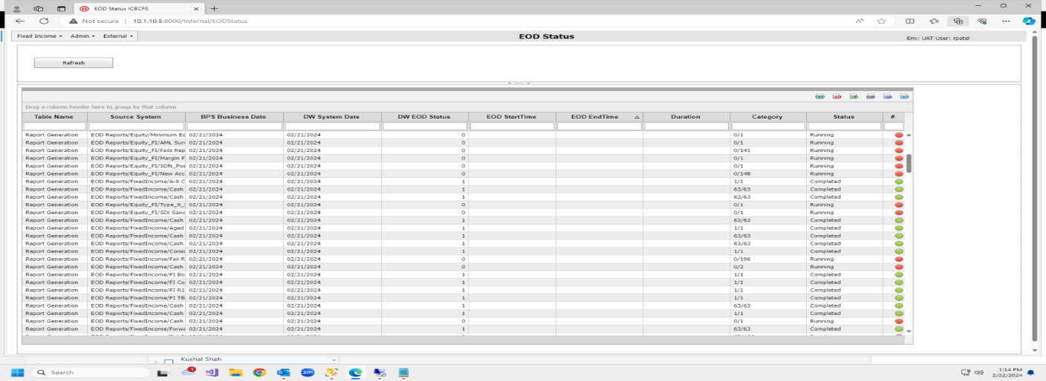

**Additional Action: If the date remains unchanged post EOD, contact Bhavesh or Ravi for assistance.**